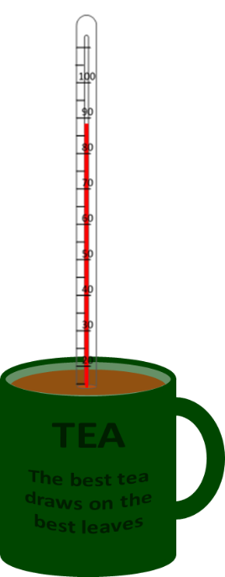
Cooling tea

A hot cup of tea cools down quickly at first, but it stays warm for ages.
What is going on?

Fill in the gaps to explain what happens when tea cools down.
You should only use the words temperature and energy.

A cup of tea.
Heating a cup of tea gives it a lot of ___________. This makes its particles move very quickly. The tea now has a higher ___________.
Some particles of tea bash into air particles and make them move faster. ___________ is transferred from the tea to the air. Losing ___________ means the tea’s ___________ goes down.
As the tea cools its particles do not move as quickly. They have less ___________ to make the air particles speed up. The tea loses ___________ more slowly and its ___________ falls more slowly too.
Physics > Big idea PMA: Matter > Topic PMA1: Heating and cooling > Key concept PMA1.2: Heating and cooling
Diagnostic question
Cooling tea

Overview
Learning focus: | If two objects at different temperatures are in contact, energy will move spontaneously from the object at the higher temperature to the object at the lower temperature.
Observable learning outcome: | Explain how energy dissipates as a hot object cools down
Question type: | focused cloze
Key words: | Temperature, dissipation

What does the research say?
The difference between temperature and a thermal store of energy is a crucial idea in the understanding of thermal concepts. When an object is warmed up its temperature rises, the amount of energy in its thermal store increases and the particles in the object move or vibrate more. All of these changes are interconnected and happen at the same time. More specifically, and at a level students may encounter later in more advanced studies, temperature is a measure of the average amount of energy in the kinetic store of the particles and the extra energy gained by the particles increases the energy in the thermal store (Institute of Physics).
This question explores students’ understanding of the differences between energy and temperature.
Ways to use this question
Students should complete the activity individually as a pencil and paper exercise. The large text on the worksheet allows it to be copied A5 size, which fits a standard exercise book.
How students fill in the gaps will show you whether they understood the concept sufficiently well to apply it correctly.
If there is a range of answers, you may choose to respond through structured class discussion. Ask one student to explain why they gave the answer they did; ask another student to explain why they agree with them; ask another to explain why they disagree, and so on. This sort of discussion gives students the opportunity to explore their thinking and for you to really understand their learning needs.
Differentiation
You may choose to read the sentences to the class, so that everyone can focus on the science. In some situations it may be more appropriate for a teaching assistant to read for one or two students.

Expected answers
A cup of tea.
Heating a cup of tea gives it a lot of energy. This makes its particles move very quickly. The tea now has a higher temperature.
Some particles of tea bash into air particles and make them move faster. Energy is transferred from the tea to the air. Losing energy means the tea’s temperature goes down.
As the tea cools its particles do not move as quickly. They have less energy to make the air particles speed up. The tea loses energy more slowly and its temperature falls more slowly too.
How to respond - what next?
The transfer of energy from the hot tea and into the thermal store of the air is called dissipation.
We know that energy has been transferred because the particles of the air are now moving more quickly, and the particles of the tea are moving more slowly. Temperature is a measure of how quickly the particles are moving.
It is relatively common for students to have the misunderstanding that temperature can be transferred. A key difference between temperature and energy is that energy can be transferred and temperature cannot.
If students have misunderstandings about the use of the terms energy and temperature, then it can help to follow a discussion of the answers to this question with new situations for students to describe in terms of temperature and energy. For example, to use the terms energy and temperature to describe what happens when a metal baking tray is put into a hot oven.
The following BEST ‘response activity’ could also be used in follow-up to this diagnostic question:
- Response activity: Warm scarf
Acknowledgments
Developed by Peter Fairhurst (UYSEG).
Images: Peter Fairhurst (UYSEG).
References

